Year | Events, Submissions, Activities
2002 | - Great Barrier Island Charitable Trust formed with vision of rat and feral-cat free island
2003 | - Adopt plan to research the ecological and economic benefits to Great Barrier Island of pest-free status, and develops mission statement and policies  - Trust has first Open Day at Windy Hill
2004 | - First issue of ‘Environmental News’  - Subsidises cat spaying (petscan)  - Contributions to DOC Conservation  - Management Strategy (CMS)  - Open Days Benthorn Farm and Glenfern Sanctuary
2005 | - Trust runs Summer Lecture series with guest speakers  - Trust runs first of three trips to Tiritiri Matangi Island for islanders to see  results on a rat-free island  - Website started  - First Primary School Prizes for environmental awareness | 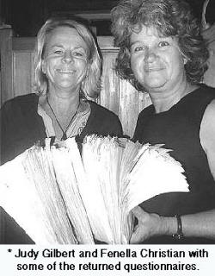
2006 | - ‘Referendum’ gives massive support for Trust to continue research into methods for rat and feral cat eradication  - Presentation to Auckland Council on World Heritage Status  - Trust commenced two year program of community bird counts  - Rat research papers placed in local library
2007 | - First “Rat attack” workshops  - First community kaka count  - Submissions to Auckland District Plan  - Contributions to ARC Biosecurity Management Plan for GBI and Regional Pest Management Strategy  - Trustees attend “Rats, humans and their impacts on Islands” conference in Hawaii and present paper
2008 | - Trust submits on Kiwi recovery plan  - Trust draws attention to algal bloom and stream quality in Tryphena  - Trust starts research for State of GBI Environment Report (SOER)  - Three “Rat Attack” workshops  - Carbon credits and weeds workshops  - Sponsorship by Natural Habitats
2009 | - State of Environment Report occupies Trust most of year  - Trust produces report to Council on state of Tryphena streams  - Final Report on Bird Counts  - Ngati Rehua representative at Trust meetings  - DOC and Local Board representatives at Trust meetings  - Trustees publish “Prospects for the eradication of rats” paper in “Biological Invasions”
2010 | 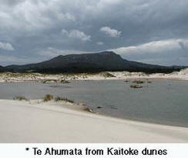  - SOER published and widely acclaimed.  - Attended and presented paper at International “Island Invasives” conference  - Trust submits on proposed DOC cut-backs to staffing on GBI and relocation of  managerial team to Warkworth.  - Trust submits on proposed changes to Schedule 4 of Mining Act (Te Ahumata–Photo) and presents at public hearings  - Sue Daly (former trustee) elected to Community Board  - Ngati Rehua commence process for return of kokako to Te Paparahi  - Work with Hauraki Gulf Forum  - Input to DOC’s Conservation Management Strategy
2011 | - Trustees publish “Running the gauntlet” paper about the process of pest eradication on an inhabited Island in “Island Invasives: Eradication and Management” (International Union for the Conservation of Nature)  - Local Board forms Environmental Strategy Planning Committee (ESPC)  - Trust revises long-term strategic plan and submits ideas to ESPC  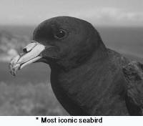  - 17 October, founding trustee Tony Bouzaid dies leaving a legacy of environmental initiatives and dedication to the GBI community  - Kauri die-back seen as threat to GBI kauri forest  - Hui to support the return of Kokako hosted by Iwi at Motairehe  - Black Petrel Action Group formed in response to decline of GBI’s most iconic seabird – Photo
2012 | - Trust brokers meeting between ESP and DOC representatives on community consultation process  - Local Board commits to community consultation on options for the ecological future of Great Barrier, including possible pest eradication  - Trust ensures that the long-term vision of rat eradication is included within DOC’s Conservation Management Strategy

